**AIM: Learning of various environment which can be used for python programming.**

**Solution:**

1. **Jupyter Notebook**

The Jupyter Notebook is an incredibly powerful tool for interactively developing and presenting data science projects. A notebook integrates code and its output into a single document that combines visualizations, narrative text, mathematical equations, and other rich media. The intuitive workflow promotes iterative and rapid development, making notebooks an increasingly popular choice at the heart of contemporary data science, analysis, and increasingly science at large. Best of all, as part of the open source [Project Jupyter](https://jupyter.org/), they are completely free.

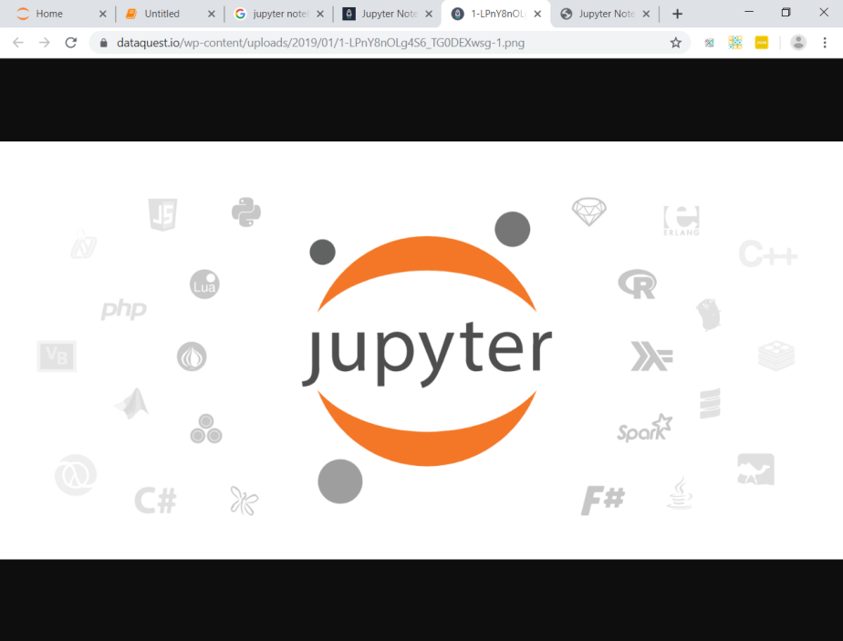

**Fig 1: Jupyter Icon**

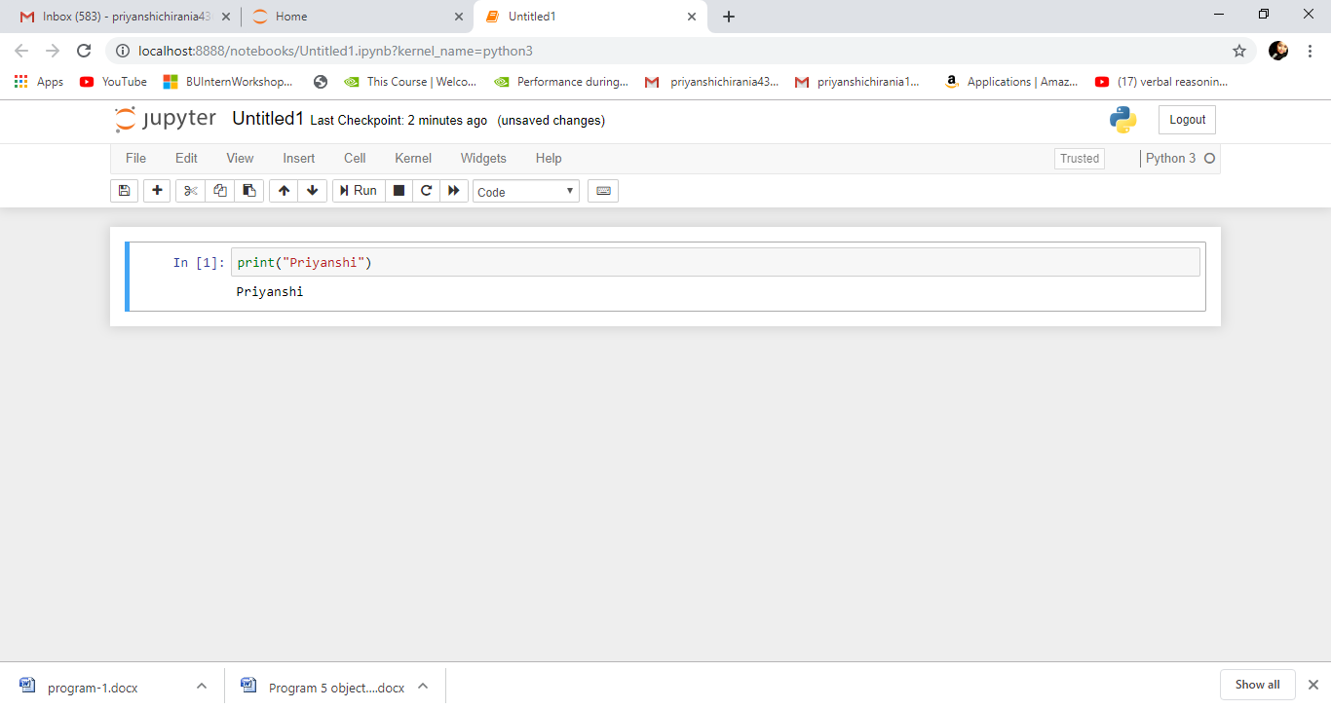

**Fig 2: Code Window of Jupyter Notebook**

1. **Spyder**

Spyder, the Scientific Python Development Environment, is a free integrated development environment (IDE) that is included with Anaconda. It includes editing, interactive testing, debugging and introspection features.

It is an [open source](https://en.wikipedia.org/wiki/Open-source_software) cross-platform [integrated development environment](https://en.wikipedia.org/wiki/Integrated_development_environment) (IDE) for scientific

programming in the [Python language](https://en.wikipedia.org/wiki/Python_(programming_language)). Spyder integrates with a number of prominent packages in the scientific Python stack, including [NumPy](https://en.wikipedia.org/wiki/NumPy), [SciPy](https://en.wikipedia.org/wiki/SciPy), [Matplotlib](https://en.wikipedia.org/wiki/Matplotlib), [pandas](https://en.wikipedia.org/wiki/Pandas_(software)), [IPython](https://en.wikipedia.org/wiki/IPython), [SymPy](https://en.wikipedia.org/wiki/SymPy) and [Cython](https://en.wikipedia.org/wiki/Cython), as well as other open source software. It is released under the [MIT license](https://en.wikipedia.org/wiki/MIT_license).

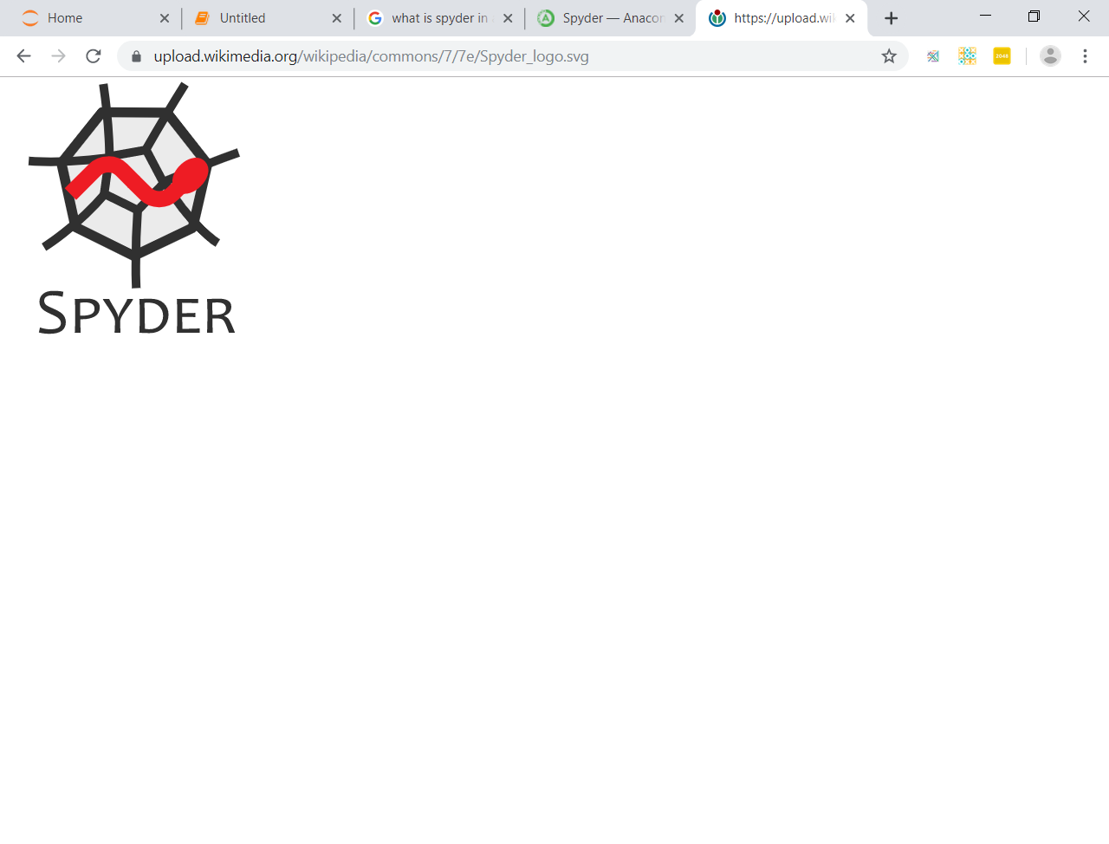

**Fig 3: Spyder Icon**

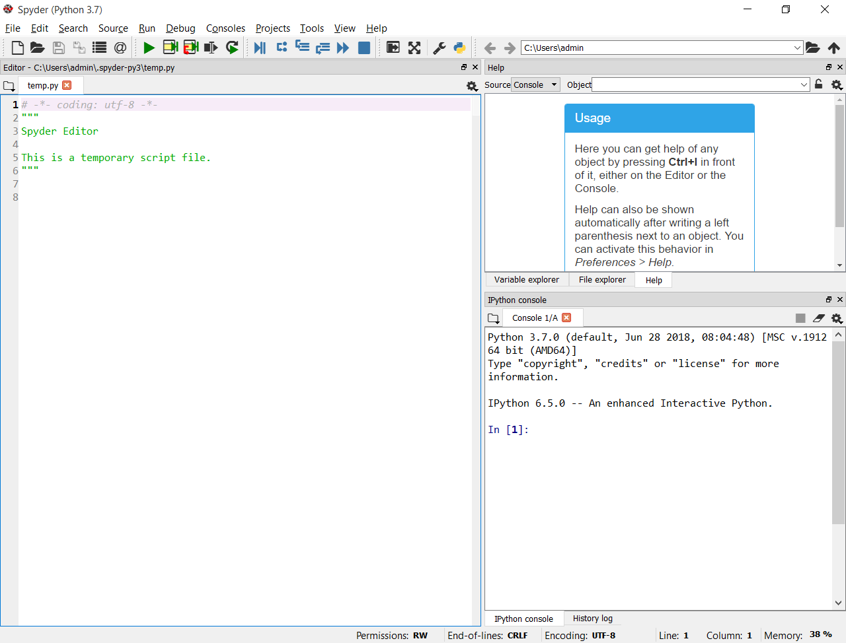

**Fig 4: Code Window of Spyder**

1. **Pycharm**

PyCharm is an integrated development environment (IDE) used in computer programming, specifically for the Python language. It is developed by the Czech company JetBrains. It provides code analysis, a graphical debugger, an integrated unit tester, integration with version control systems (VCSes), and supports web development with Django as well as Data Science with Anaconda.



**Fig 5: Pycharm Logo**

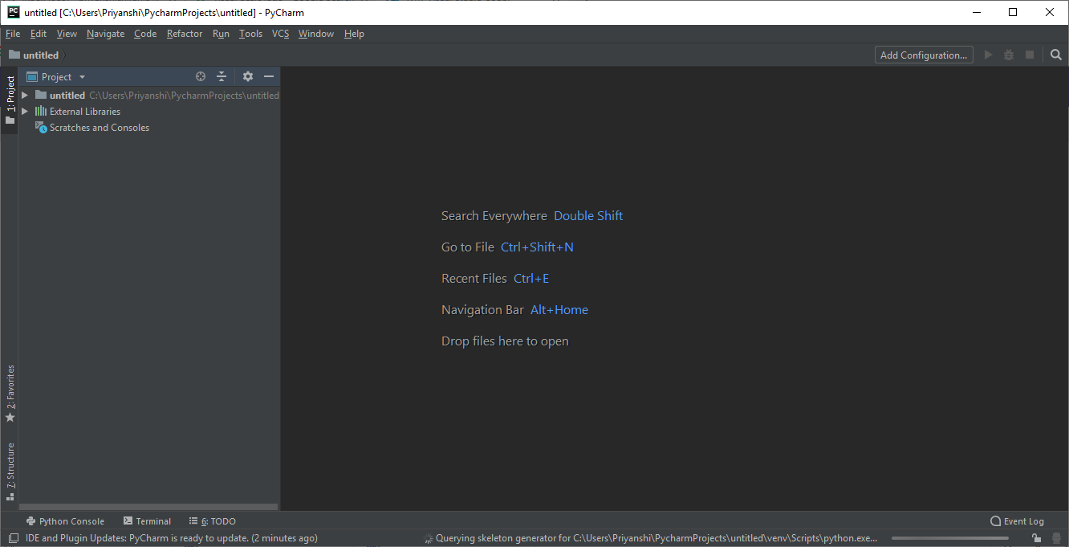

**Fig 6: Code Window of Pycharm**

1. **Visual Code Studio**

Visual Studio Code combines the simplicity of a source code editor with powerful developer tooling, like IntelliSense code completion and debugging.

First and foremost, it is an editor that gets out of your way. The delightfully frictionless edit-build-debug cycle means less time fiddling with your environment, and more time executing on your ideas.

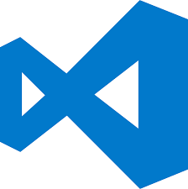

**Fig 7: Visual Code Studio Logo**

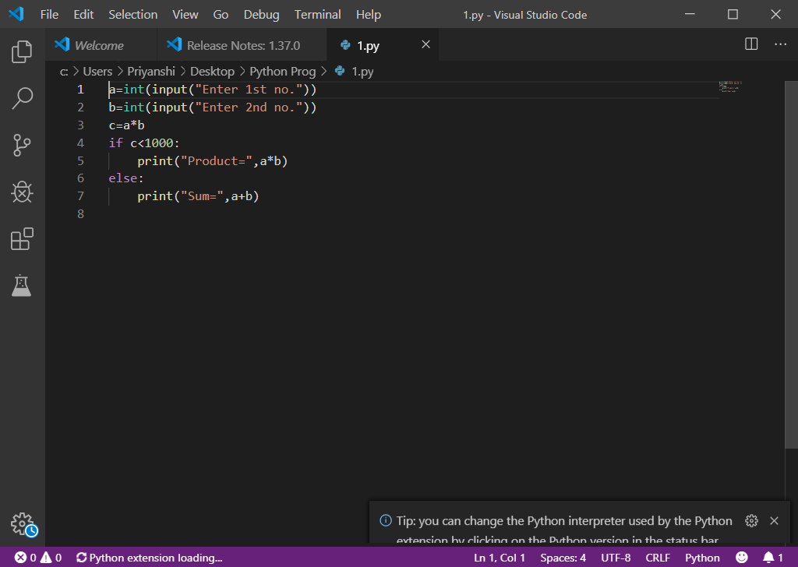

**Fig 8: Code Window of Visual Code Studio**